Sandwell Academy

Year 7

Transition booklet

Name:

Primary school:

Welcome to Sandwell Academy

Welcome to Sandwell Academy. You will be joining us shortly in September and we look forward to meeting you. Before then, we would like to tell you more about the academy to help you prepare for the move.

This is an exciting time ahead and you are joining a fantastic school, Sandwell Academy prides itself on achievement and places all students at the heart of learning. The Academy sets high standards for all students and through excellent teaching challenges students to be the best they can be.

Making the move from primary to secondary school is called transition. This is a big change and might make you feel nervous or worried but also excited. There will probably be lots of questions that you want to ask and hopefully this booklet will give you the answers to these questions.

This is your transition booklet, which gives you information about the academy along with fun activities to complete. Please complete this booklet to the best of your ability and bring it with you on the first day in September.

This booklet is split into 3 sections:

Section 1: All about me

Section 2: About my new school Sandwell Academy

Section 3: Subject tasks

Section 1: All about me

Before we talk about your new school, tell us about you. What do you want your new teachers to know about you?

My picture (attach/draw a picture of yourself)

Name:……………………………………………………………

Primary school:………………………………………………….

Birthday:………………………………………………………...

Where do I live?:………………………………………………...

Who do I live with?:……………………………………………..
Section 1: All about me

About school and learning

My favourite subjects in school are:……………………………………………………………………………………………………………………………………………………………………………………………………………………………………………………………………………………

My least favourite subjects in school are:
……………………………………………………………………………………………………………………………………………………………………………………………………………………………………………………………………………………

I learn best when:
……………………………………………………………………………………………………………………………………………………………………………………………………………………………………………………………………………………

The things that help me to learn are:
……………………………………………………………………………………………………………………………………………………………………………………………………………………………………………………………………………………

What I might need help with:
……………………………………………………………………………………………………………………………………………………………………………………………………………………………………………………………………………………

Section 1: All about me

My thoughts on moving to Sandwell Academy

When I start Sandwell Academy, I hope to:……………………………………………………………………………………………………………………………………………………………………………………………………………………………………………………………………………………………………………………………………………………………………………………………………………………………….

When I start Sandwell Academy, I am looking forward to:
………………………………………………………………………………………………………………………………………………………………………………………………………………………………………………………………………………………………………………………………………………………………………………………………………………………………

I am nervous about:
……………………………………………………………………………………………………………………………………………………………………………………………………………………………………………………………………………………………………………………………………………………………………………………………………………………………….

Section 1: All about me

Facts about me:

List 3 words to describe my personality: 1.
2.
3.
Favourite colour:
…………………………………………………………………….

Favourite film/TV show:
…………………………………………………………………….

I am most happy when:
……………………………………………………………………..

Favourite food:
……………………………………………………………………..

If I were famous I would be:
……………………………………………………………………..

My dream job would be:
……………………………………………………………………..

The place I would most like to visit:
……………………………………………………………………..

If I were a superhero I would be:
……………………………………………………………………..

Favourite book:
……………………………………………………………………..

Senior management team (SMT):
Section 2: About my new school Sandwell Academy
Mr Williams (Head teacher)

Task 1: Have a look at the Sandwell Academy website to find out the roles of other SMT staff:

SMT staff name | Job role | SMT staff name | Job role
Mrs Povey |  | Mrs Bladen
Mr Hull |  | Mrs Jones
Mr Lally |  | Miss Humphries
Mr Pugh |  | Mrs Chapman
Mr Mills |  | Mr Kangh
Mr Moore |  | Mrs Judge
Mrs Walton

Section 2: About my new school Sandwell Academy
Department information:

Task 2: Using the school website, find out the names of staff who work in the different departments:
Department | Staff
Maths
English
Science
Humanities
Modern Foreign Languages
Business
ICT
Physical Education
Performing Arts
Design Technology & Art
Inclusion
Pastoral

Section 2: About my new school Sandwell Academy

Expectations: The Student Charter

Sandwell Academy expects all students to show good behaviour, a positive attitude towards learning and to show respect for other students and staff. The school has expectations for students to follow as part of the ‘Student Charter’, which can be found at: http://www.sandwellacademy.com/page/student-charter

Some of the expectations include:

1. Always wear official academy dress.

2. Students must show a positive attitude to learning.

3. Everyone must be safe and must not behave in an aggressive or threatening way. Bullying will not be tolerated.

4. Be sure to treat all facilities, and especially the ICT facilities, properly and with a high level of care.

5. The Academy actively promotes healthy lifestyles and encourages students to eat a balanced diet. Chewing gum, sweets and fizzy drinks are not allowed at the Academy and will be confiscated.

6. You may bring mobile phones into the academy but must be switched off as soon as you enter the academy.
Section 2: About my new school Sandwell Academy

Task 3: Student Charter task
Pick three of the expectations above and say why you think such rules are important​?

Rule 1:

Rule 2:
Rule 3:
Section 2: About my new school Sandwell Academy

Academy uniform

Below are pictures of the academy uniform, which can also be found at: http://www.sandwellacademy.com/page/info-uniform.
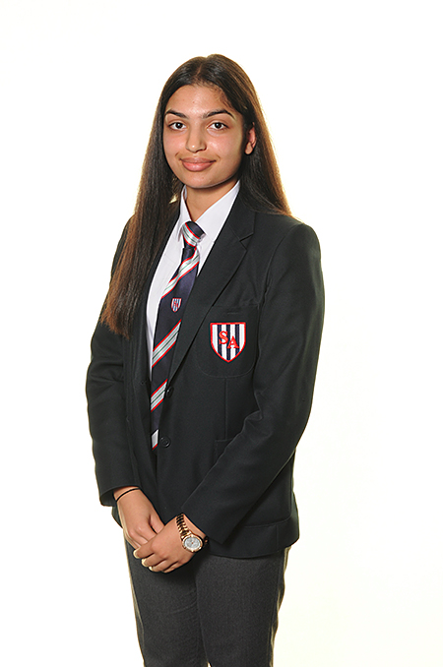

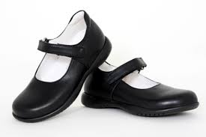

Portfolio:
Students must carry their portfolio with them at all times. Portfolio’s will contain the books that you need for all lessons that day.
Things to remember:

1. Only one pair of plain stud gold or silver earrings are allowed, other piercings are not allowed.
2. No extreme hair styles.
3. No nail varnish.
4. No make-up for year 7 and 8.
5. No variation on uniform or PE kit is allowed.

PE Kit
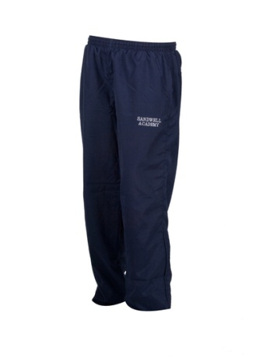

Task 4: Design my own school uniform
Section 2: About my new school Sandwell Academy

Looking at the pictures above and using the space below, have a go at trying to draw a picture of what you would look like wearing the uniform.

Section 2: About my new school Sandwell Academy

Task 5: Design my own school badge

Using the template below, have a go a creating a new school badge for Sandwell Academy. Use your imagination and be creative as possible.

Section 2: About my new school Sandwell Academy

The school day
The school day is divided up into 4 main parts: 1a, 1b, 2a & 2b. Everyday there is a Personal Tutorial (PT) session with your personal tutor in your small tutor group. From Monday to Thursday, you can take part in a Session 3 activity at the end of the school day. This is where you can take part in lots of fun learning activities.

Monday to Thursday

Break 3:20pm – 3:40pm

Session 3 3:40pm – 5:10pm

Students Depart 5:10pm - 5:15pm

Monday to Friday

Students Arrive 8:05am - 8:15am
All students in lesson 8:20am

Session 1a
8:30am - 10:05am
(Includes 15 minute breakfast)

Session 1b
10:10am - 11:30am

Personal Tutorial
11:35am - 11:50am

Session 2a
11:55am - 1:55pm
(Includes 40-minute lunch)

Session 2b
2:00pm - 3:20pm

Students Depart
3:20pm

Section 2: About my new school Sandwell Academy

My journey to school

How are you going to travel to school? Put a tick by how you will get to school when you start in September.
Coach
Train/tram
Public bus

Walk

Car

Cycle

Planning my journey:

Have a think about your journey to school, from the time you get up in a morning and the routine you might need when preparing to leave for school.

Use the space below to write a plan for getting to school.

…………………………………………………………………………………………………………………………………………………………………………………………………………………………………………………………………………………………………………………………………………………………………………………………………………………………………………………………………………………………………………………………………………

Section 2: About my new school Sandwell Academy

Subjects:

In school you will have the opportunity to study and learn different subjects. These subjects include:

Core subjects

Maths
English
Science
Additional subjects

Art
PE
Business
History
Geography
Music
Performing Arts
Spanish
Product design

Section 2: About my new school Sandwell Academy

Timetable

Below is an example timetable of a student at S.A. You will be given your timetable when you start in September.

Time/Day | Monday | Tuesday | Wednesday | Thursday | Friday
1a (8:30 am – 10:05 am) | 7PE-4  Mr S Follis  Prac | 7En-4  Miss A Round  St1 | 7PE-4  Mr R Duffield  Prac | 7PA-4  Miss L Hubble  DaSt | 7DT-4  Mrs E Izadpanah  ProdDes2
1b (10:10 am- 11:30 am) | 7Hi-4  Mr S Sweet  St22 | 7Ma-3  Mrs L Akay  St16 | 7PE-4  Mr C Ferguson | 7Ma-3  Miss S Douras  St7 | 7Ma-3  Mr M Sturley  St1
PT | KKF  Mrs K Fellows  St3 | KKF  Mrs K Fellows  St3 | KKF  Mrs K Fellows  St3 | KKF  Mrs K Fellows  St3 | KKF  Mrs K Fellows  St3
2a (11:55 am – 1.55 am) | 7En-4  Miss F Martin  EnLB1 | 7Gg-4  Mrs J Powell  St17 | 7En-4  Miss F Martin  St1 | 7PA-4  Mr A Kearns  MR2 | 7Sc-4  Ms T Ludy  Lab2
2b (2:00 am – 3:20 am) | 7MaCUp-2  Mr R Khuttan  MaLB3 | 7Art-4  Mr K Tsang  ArtDes2 | 7Sp-4  Miss C Spillane  St16 | 7DT-4  Mrs E Izadpanah  ProdDes2 | 7Sc-4  Ms T Ludy  Lab2
Study the timetable and answer the questions below:

1. What day(s) does the student have Spanish and what part of the day (1a, 1b, 2a, 2b)?

2. Who teaches them Science?

3. When is the students last DT lesson of the week?

4. Who is the students personal tutor (PT)?

5. What day(s) does the student go to the English Learning Base (EnLB)?
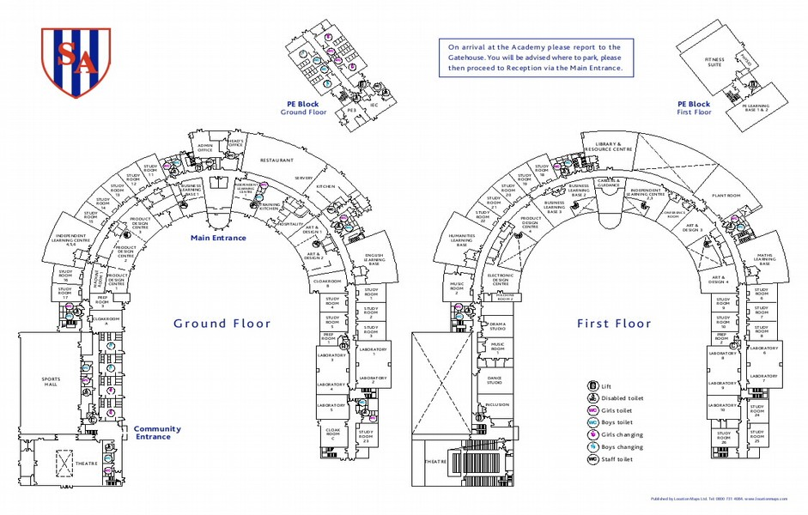
Map of Sandwell Academy
Section 2: About my new school Sandwell Academy

Personal Tutor (PT) time

Every day students will have a 20minute session with their Personal tutor and PT group. You will find out your PT in September. In PT, you will be able to socialise with other students from different year groups and have group discussions. See below an example of things covered in PT:

Monday – video broadcast of events that have happened in the previous week including sporting achievements. There are also important messages about the week ahead.

Tuesday – Sign homework logs. Group discussion.

Wednesday – Citizenship & group discussion.

Thursday – House assembly or year group assembly.

Friday – review of the week. Group discussion.

Throughout the week, students will be encouraged to have discussions about relevant topics, such as important things in the news.

Section 2: About my new school Sandwell Academy

Session 3

From Monday to Thursday (3:40-5:10pm) students are able to sign up for a session 3 activity. These are fun and enjoyable activities to develop student participation and learning. Session 3 timetables change every term, and students must sign up for at least one activity per term. Some activities include:
Multi-sports
Athletics
Yoga
Homework club
Reading club
Pyramid club
Music school
Performing arts
Food and nutrition
Business & IT
Art
Cadets

Football
Netball
Basketball

Section 2: About my new school Sandwell Academy

Teaching rooms and facilities

Sandwell Academy is an outstanding school, which gives students a lot of opportunities to learn different things when in class but also during extra-curricular activities. You will also gain access to state of the art facilities and modern equipment across the academy. Below are some pictures to show what the academy is all about.

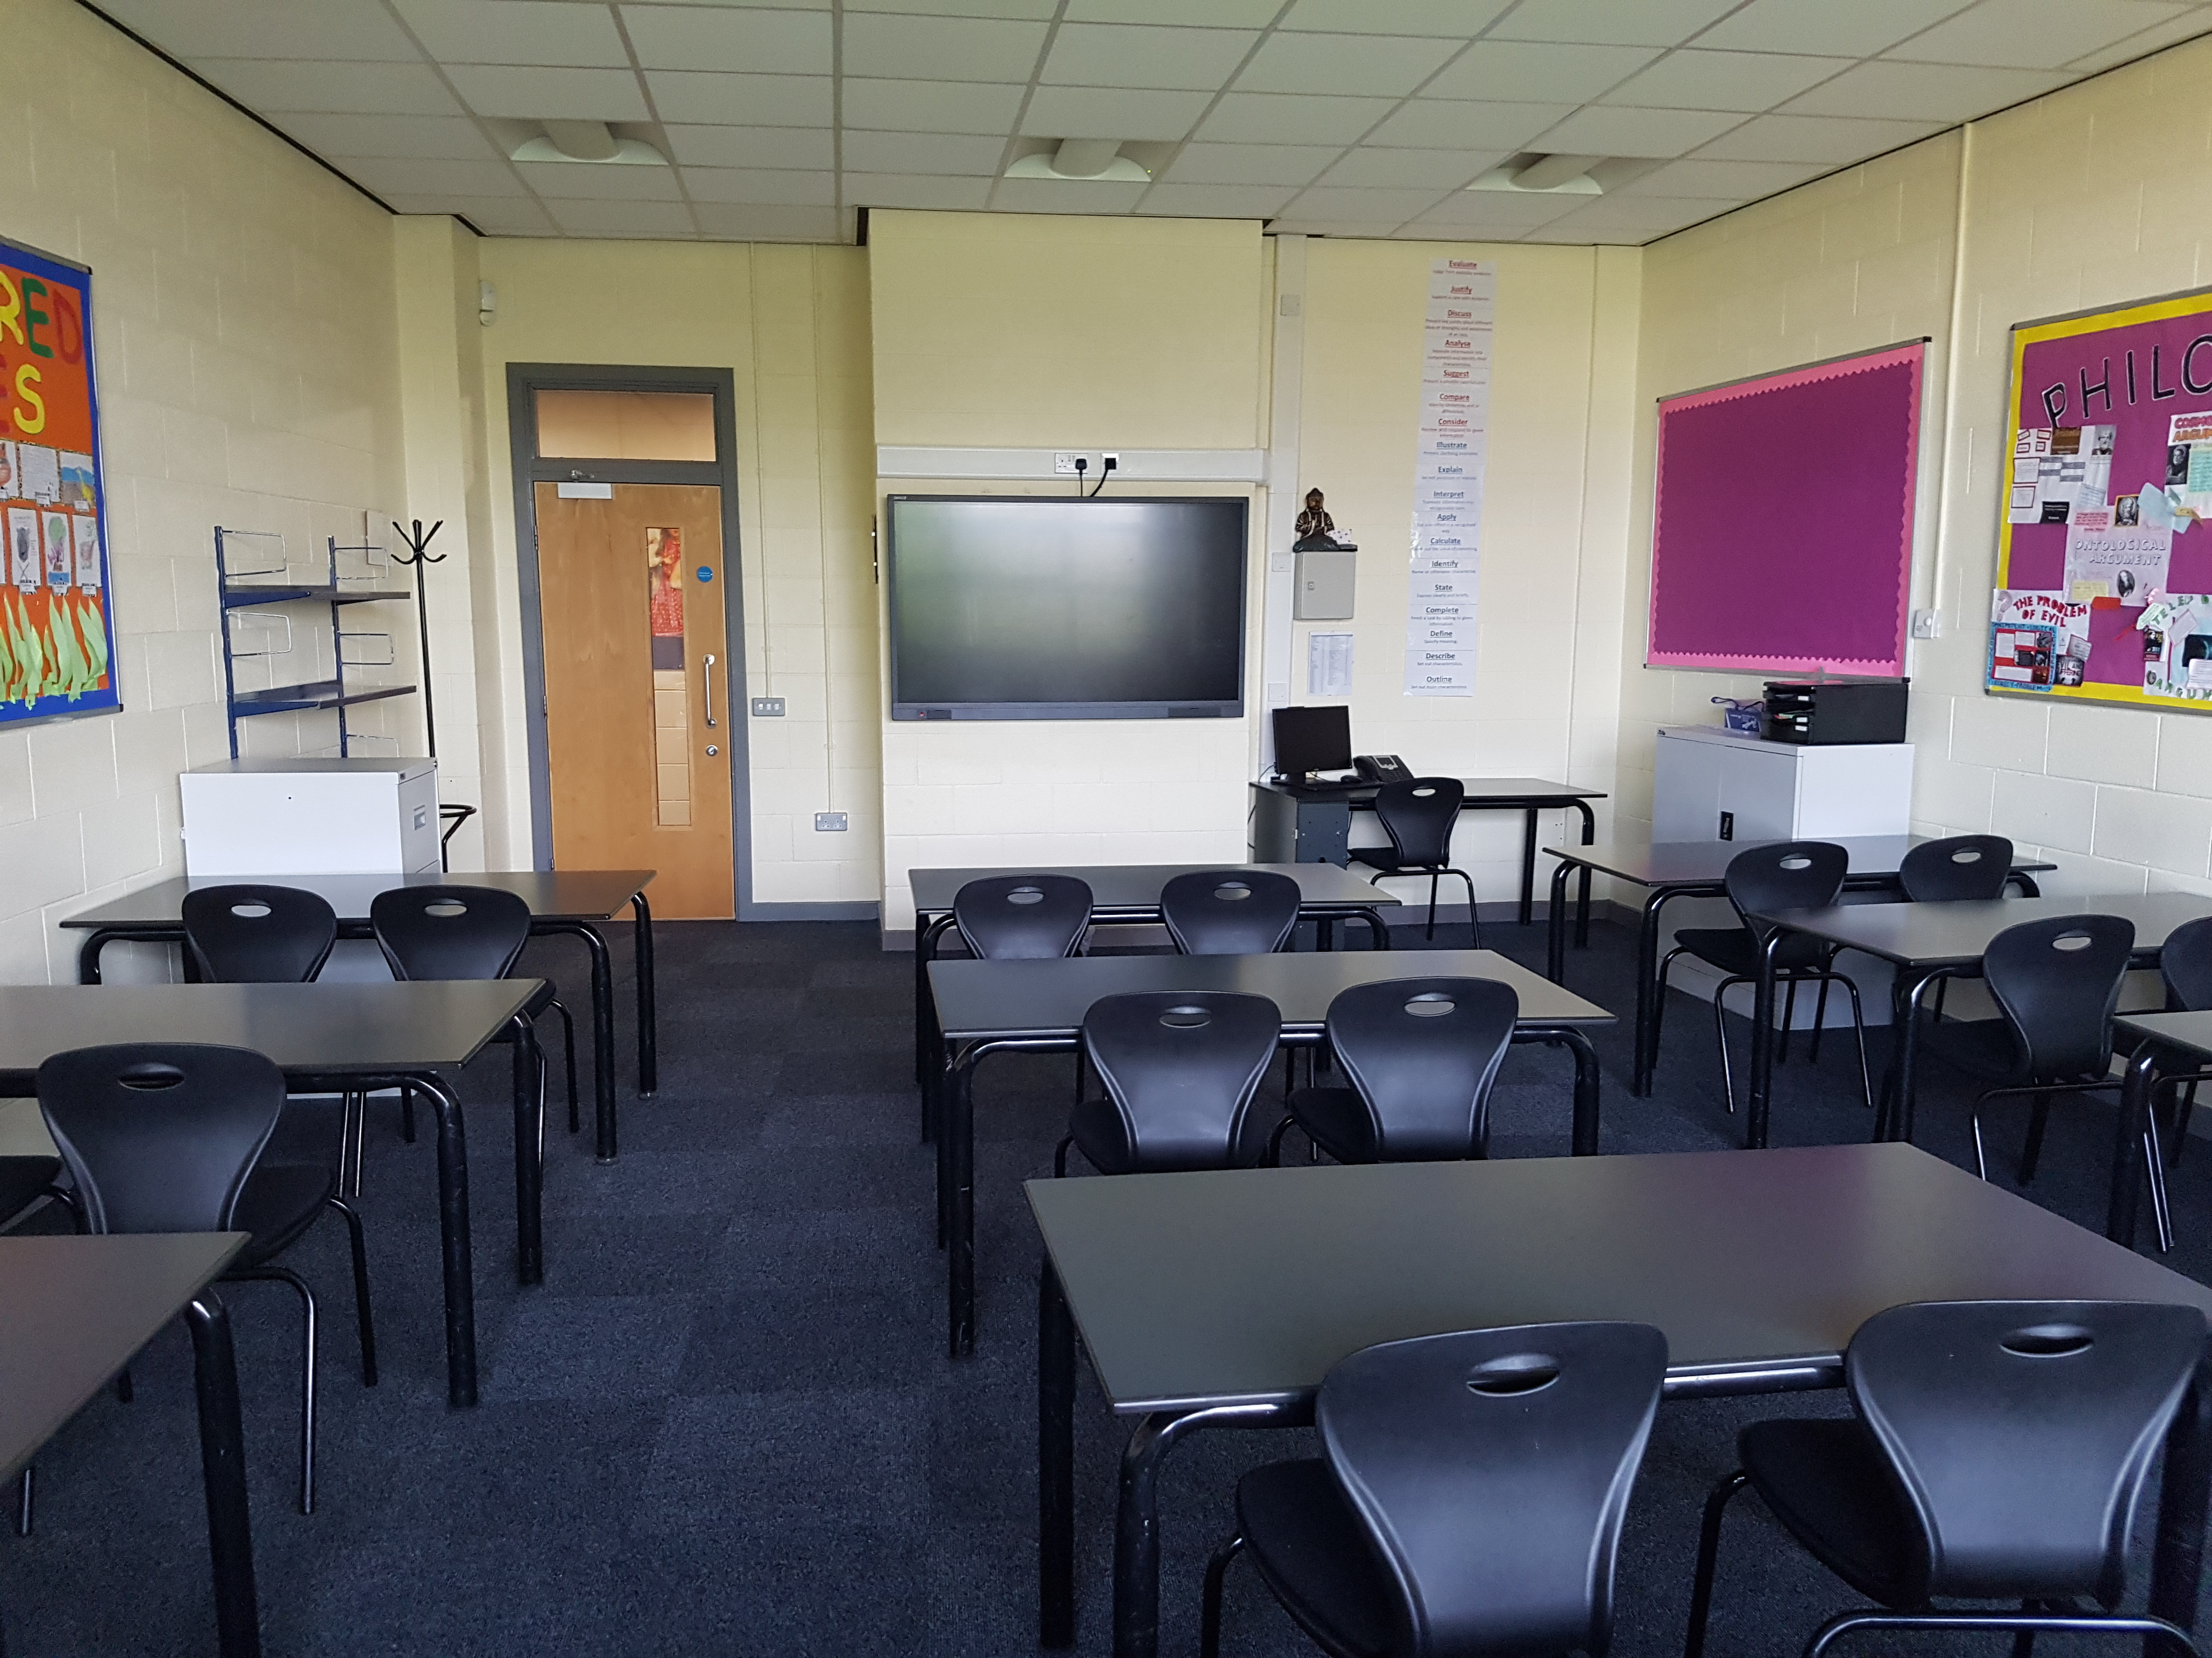

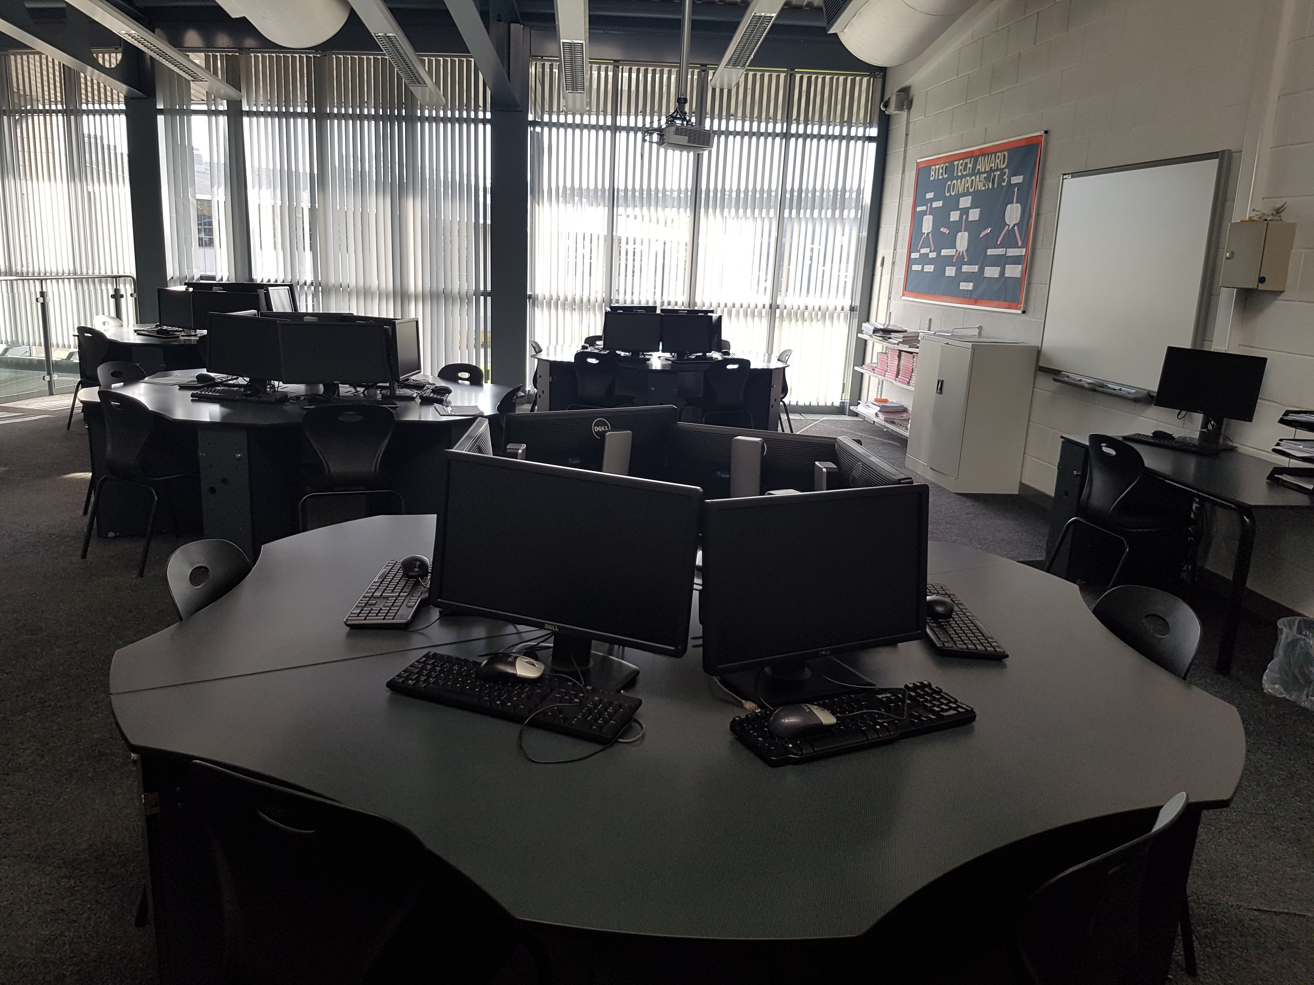

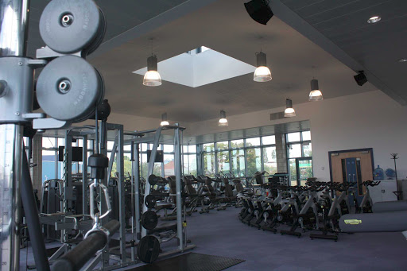

Music

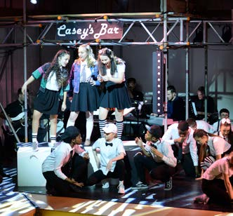
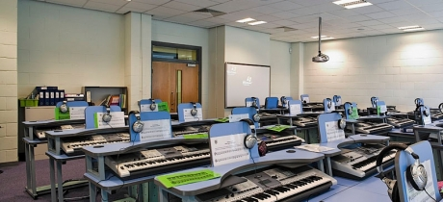
Section 2: About my new school Sandwell Academy

School restaurant

During the school day, at breakfast and lunch time, students will be able to eat in the school restaurant and buy food if they want to. Sandwell Academy encourages students to eat a balanced diet and offers food from the different food groups of the ‘eat well plate’.

Sandwell Academy uses a Biometric Trust-e Cashless System. This is used to purchase food and drink from the academy restaurant. It requires all students to have their thumb scanned on to the system. Your thumb is scanned at the till when you make a purchase.

Example menu: (Prices as at June 2020)
Breakfast | Main course | Deserts & Drinks
Toast £0.45p | Plain sandwich £1.45 | Fresh fruit £0.35
Toasties £1.65p | Filled sandwich £1.65 | Apple crumble £0.80
Cereal + Milk £0.90 | Plain baguettes £1.75 | Cupcakes £0.80
Sausage £0.60 | Filled baguettes £1.90 | Eclairs £0.80
Bacon £0.60 | Paninis £1.70 | Pink sponnge £0.80
Croissant £0.80 | Fish fingers £0.80 | Yum Yums £0.80
Baked Beans £0.60 | Pizza £1.10 | Fudge cake £0.80
Hash brown £0.25 | Beef burger £1.10 | Fruit bags £0.75
Youghurt £0.55 | Cottage pie £1.10 | Drinks
Pain au choc £0.80 | Chicken nuggets £1.10 | Small water £0.60
Spahgetti £0.60 | Pasta bake £1.10 | Large water £0.90
Bagel £0.80 | Vegetables £0.55 | Aqua Juice £0.35
Scrambled egg £0.60 | Soup £0.70 | Flavoured water £0.90
Jam/Flora | Cheese £0.55 | Fruit shoot £0.75
Breakfast muffin | Ham/Turkey slice £0.40 | Apple/organge juice £0.70
Sliced bread £0.20 | Salad pots £0.75 | Flavoured milk £0.65

The restaurant also serves special meal deals each day for a set price.
Section 2: About my new school Sandwell Academy

Designing a healthy food menu:

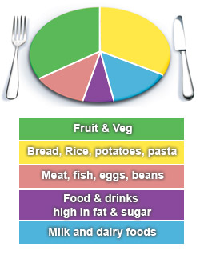
Imagine you were in charge of designing a school menu and had to make sure you included items from the different food groups of the ‘eat well plate’. What would you choose & how much would items cost? Be creative as possible.

Eat well plate:

Breakfast:
Item | Food group | Cost £
Lunch:
Item | Food group | Price £
Section 2: About my new school Sandwell Academy

Desserts/fruit:
Item | Food group | Price £

Drinks:
Item | Price £

Daily specials:
Special deals | Price £

Section 2: About my new school Sandwell Academy

Who can help me? Inclusion department

The Inclusion department is where students with support needs can get assistance. This might be support with literacy, numeracy or help to focus in class. Teaching Assistants (TAs), will help to support students in class. Students may receive 1:1 or group support through specific mentoring or learning programs. Mentors work with students to set individual targets to improve their learning and behaviour for learning. Students may also receive mentoring to help develop their social skills and to promote their well-being. In Inclusion, students can attend different clubs and activities such as Lunch Club where they can make their own lunch in the Life Skills room and also socialise with other students. The Inclusion department is co-ordinated by Mrs Jones. The SENCo is Mr Byrne
Inclusion

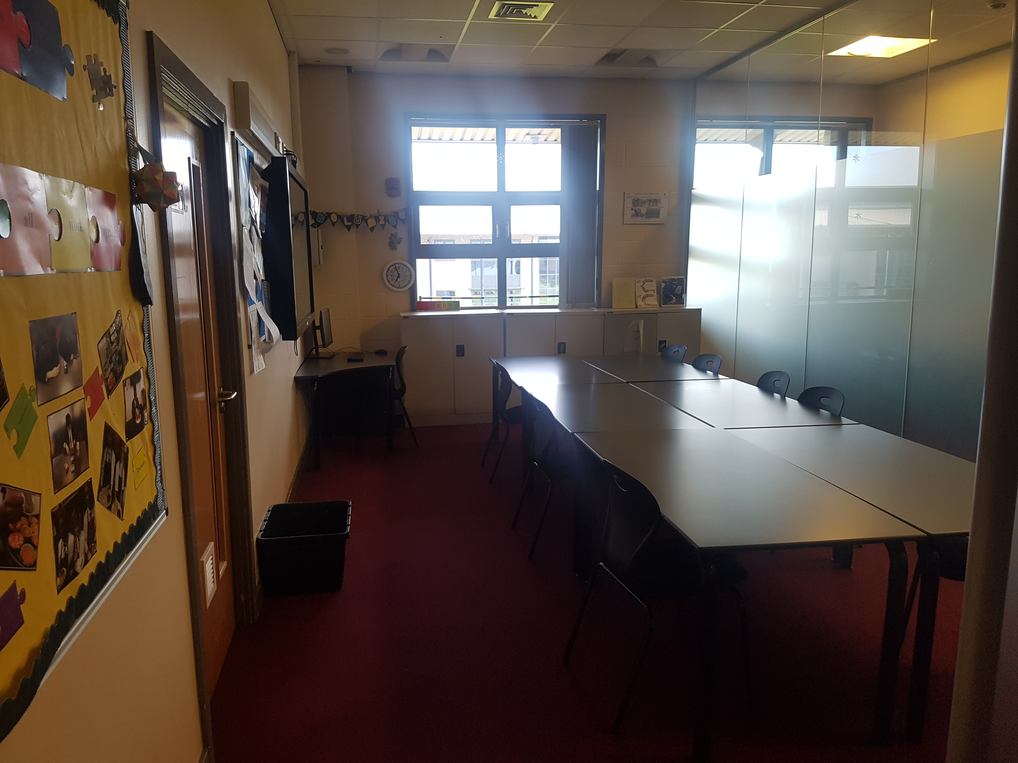

Life skills room
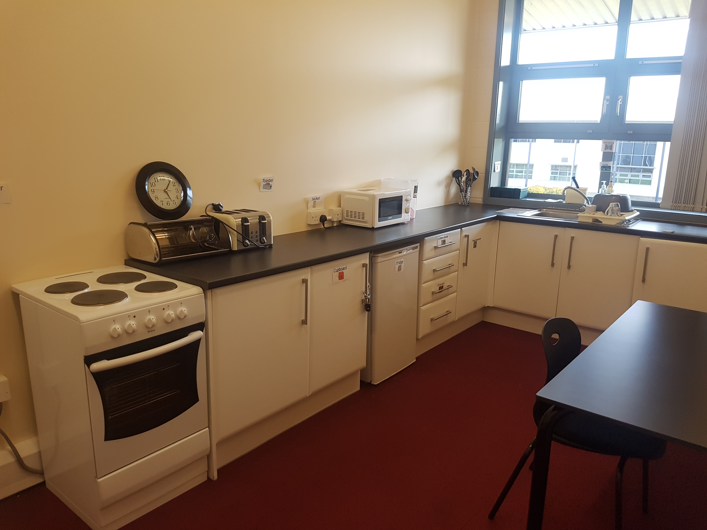
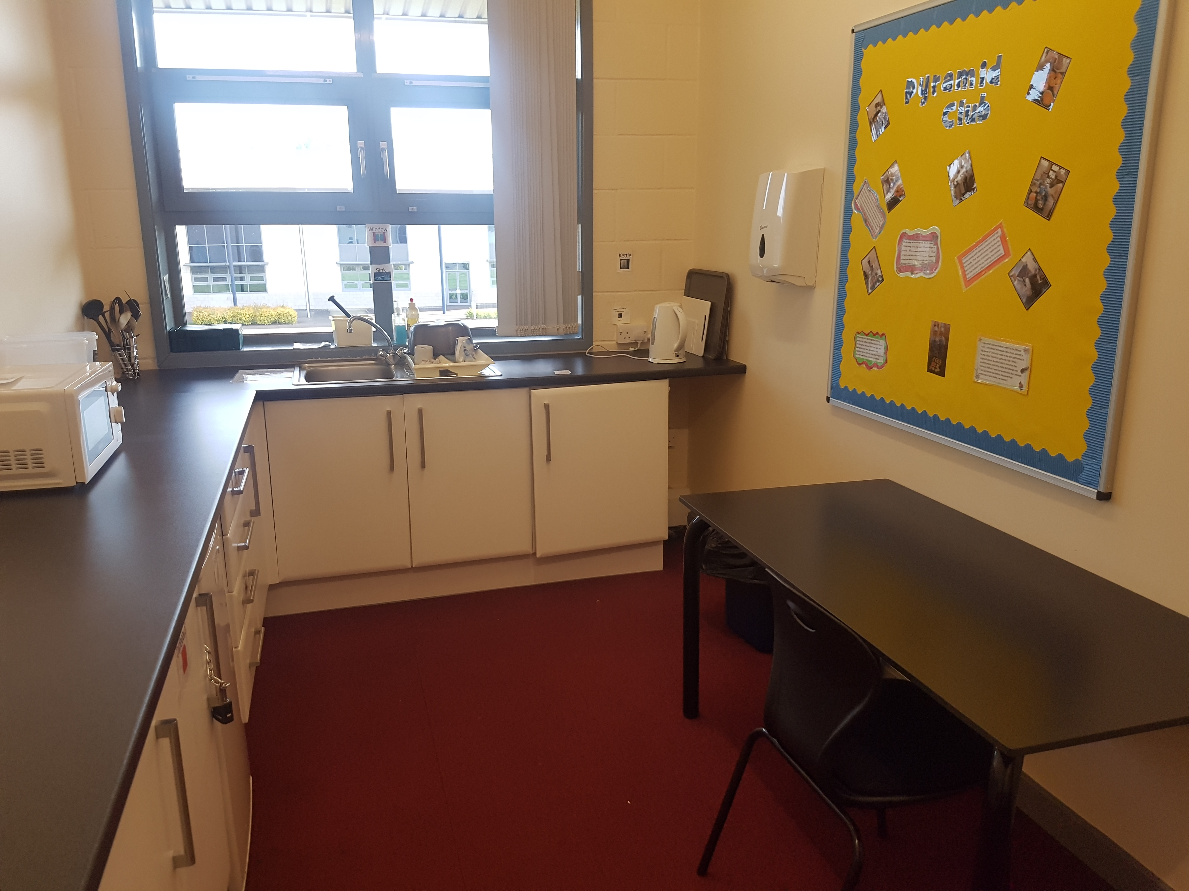

Section 2: About my new school Sandwell Academy

Some Inclusion staff profiles

Section 2: About my new school Sandwell Academy

Inclusion staff profiles

Section 2: About my new school Sandwell Academy

Inclusion staff profiles

Section 2: About my new school Sandwell Academy

Inclusion staff profiles

Section 2: About my new school Sandwell Academy

Inclusion staff profiles

Section 2: About my new school Sandwell Academy

Frequently asked questions (FAQs) :

1. Can I use my mobile phone in school? No. You can bring your mobile phone to school but this must be switched off when entering the school and put away.

2. When will I get my timetable? September.

3. Can I wear trainers to school? No. Only black school shoes.

4. Are Kickers shoes allowed? No. School shoes must be black only and not have any colour on them.

5. Can I drink in class? No. You can have your drink at breakfast and lunchtime. No fizzy drinks are allowed in school.

6. What will happen if I don’t my homework? Homework is a very important part of school life. All homework must be completed on time. If you don’t complete the work on time, then you may be given a negative mark. Parent/carers will also be told of and you will be given 24 hours to complete the work. If you complete the work and give it to the teacher, then there is no further action. If not completed, then you will have to attend a Friday review after school. You can also complete homework in the Library between 3.40pm and 5.10pm on Tuesday or Thursday as part of the Session 3 programme.

7. Can I wear earrings or make-up? Students in Year 7 & 8 are not allowed to wear make-up. One pair of silver or gold stud earrings is allowed, other piercings are also not allowed.

8. Is there a rule on hairstyles? No extreme hairstyle or colouring (including totally, partially shaved, decorated scalps including shaved lines, brightly coloured hair dyes) are allowed.

9. If I am worried or don’t know something, who can I ask for help? Ask any member of staff. We are happy to help!
Section 2: About my new school Sandwell Academy

Making Friends

The best thing about a new school is that you get to learn new things, make friends and have fun!

“The best way to make good friends is to be a good friend.”

What makes a good friend?
What ways can you think of to make new friends?
___________________________________________________________________________________________________________________________________________________

What qualities do I look for in a friend? Write down the things that you look for when meeting new friends.

1.

2.

3.

4.

5.
Section 3: Subject tasks
English

Building literacy skills is a key part of English in Year 7. You will cover lots of interesting topics including:
- How to write sentences.
- Writing descriptions.
- How to write a character analysis.
- Planning and creating stories.
- Reading different texts.

Spelling, punctuation and grammar (SPAG) are important parts in English and teachers will help students to work on these areas. How is your SPAG? Have a go at the SPAG activities below (Task 1& 2) and try your best to answer the questions. Don’t worry if you find some of the questions hard, just have a go and see what you can answer. For more help use the following link: https://www.bbc.co.uk/bitesize/topics/z7vdy9q

Task 1: Spelling

Look at the passage below and underline any words that you think are misspelt. How many can you spot?
There was a boy named Ben who had a pasion for sceince. At school, Ben loved to do new experements and find out new things. He enjoyd learning and hoped one day to be a scientist. Ben would have vivid dreams about becomin a scientist, which excited him and often kept him awake at night time. Last summer, ben visitid a reserch center in Birmingham and was given an opportunity to shadow a group of scientiest who were working on a novel technologie for reducing carbon emisions in factories across the United Kindom. Ben was intrigued by this as he had always wanted to help protekt the countrie. Ben lernt so much from his time at the center and this inspired him to think about other ways he could help save the planett. Ben had lots of ideas but wasn’t sure what he could do with them.

Section 3: Subject tasks
English

He approched his science teacher in school, Mr Bennett and told him about his ideas. “There fantastik, Mr Bennett said” as he looked at me in
bewilderment. “How did you come up with such creativ ideas?” Mr Bennett said. Ben told him about all the research he had conducted but didn’t know if it was worthwile looking into them. Mr Bennett said that he would help Ben with this and sugessted how he could put this into practise. Ben was happy that someone beleivd in him and his ideas and he went home to tell his parents all about his experience.

Task 2: Punctuation- Full stops and Capital letters

Look at the sentences below and put where you think full stops should go and put in any capital letters.
Rules: A full stop is a punctuation mark (.) used at the end of a sentence or an abbreviation.

1. john always found maths hard in school he hated everything about maths and disliked his teacher Mrs Tulley who was always picking on him by asking him questions.

2. The zoo keeper loved his job he always wanted to work with animals and spent several years studying animals the only animal he was afraid of were snakes. when he was young, he visited a zoo with his family they spent time looking at the different reptiles and was asked by one of the keepers whether he wanted to hold a snake He was reluctant at first but thought it was a good experience for him he didn’t know what to expect but the sight of the snake coming closer to him made him feel nervous when it came to touching the snake, he backed away and said he couldn’t do it from this moment he has always been scared of snakes

3. daisy was about to take her GCSE’s and she was excited and anxious at the same time she didn’t want to mess anything up as she planned to be
Section 3: Subject tasks
English

a school teacher in the future. her mum had given her some great advice, but for daisy these were just words and her worries overtook any positive words from her mum she had studied a lot and spent so much time revise her notes the day came for her first exam and Daisy was a nervous wreck to the point where she doubted her own ability Daisy’s mind went blank just before the exam and she panicked Daisy then remembered some of the positive words her mum had said to her and began to believe them these helped to calm her nerves and when she walked into the exam she felt relaxed and confident she could do well

Descriptive writing

Using the spider diagram below to help plan your ideas, described your experiences of being at home during ‘lockdown’. You can include things such as:

- What you have been doing whilst at home.
- Your thoughts and feelings about the situation.
- What things you are looking forward to when you start back.

Lockdown

Section 3: Subject tasks
English

My lockdown description:…………………………………………………………………………………………………………………………………………………………………………………………………………………………………………………………………………………………………………………………………………………………………………………………………………………………………………………………………………………………………………………………………………………………………………………………………………………………………………………………………………………………………………………………………………………………………………………………………………………………………………………………………………………………………………………………………………………………………………………………………………………………………………………………………………………………………………………………………………………………………………………………………………………………………………………………………………………………………………………………………………………………………………………………………………………………………………………………………………………………………………………………………………………………………………………………………………………………………………………………………………………………………………………………………………………………………………………………………………………………………………………………………………………………………………………………………………………………………………………………………………………………………………………………………………………………………………………………………………………………………………………………………………………………………………………………………………………………………………………………………………………………………………………………………………………………………………………………………………………………………………………………………………………………………………………………………………………………………………………………………………………………………………………
Section 3: Subject tasks
English

Creating a fairy tale

In Year 7 you will study different fairy tales. A fairy tale is a make-believe story that often includes magical events and imaginary creatures. Traditional fairy tales include: Cinderalla, Snow White, Rapunzel, Jack & the Beanstalk and Hansel & Gretel.

Using the templates below, have a go a creating your own fairy tale with you as the main character. You can be as creative as you want. To help you plan your story out, use the template to plan what you are going to include at the beginning, the middle of the story and the end. Use the character profile to create your character.

Fairy tale story planner:
Beginning

Middle

End

Section 3: Subject tasks
English

My fairy tale: Character profile
Character name:

Age:

Description: (draw
your character)

Where do they live?:

Personality:

What are they thinking?

What do others think about them?

What has happened in their life? Key events:

Section 3: Subject tasks
English

My fairy tale:

Now write your story below:

……………………………………………………………………………………………………………………………………………………………………………………………………………………………………………………………………………………………………………………………………………………………………………………………………………………………………………………………………………………………………………………………………………………………………………………………………………………………………………………………………………………………………………………………………………………………………………………………………………………………………………………………………………………………………………………………………………………………………………………………………………………………………………………………………………………………………………………………………………………………………………………………………………………………………………………………………………………………………………………………………………………………………………………………………………………………………………………………………………………………………………………………………………………………………………………………………………………………………………………………………………………………………………………………………………………………………………………………………………………………………………………………………………………………………………………………………………………………………………………………………………………………………………………………………………………………………………………………………………………………………………………………………………………………………………………………………………………………………………………………………………………………………………………………………………………………………………………………………………………………
Section 3: Subject tasks
English

…………………………………………………………………………………………………………………………………………………………………………………………………………………………………………………………………………………………………………………………………………………………………………………………………………………………………………………………………………………………………………………………………………………………………………………………………………………………………………………………………………………………………………………………………………………………………………………………………………………………………………………………………………………………………………………………………………………………………………………………………………………………………………………………………………………………………………………………………………………………………………………………………………………………………………………………………………………………………………………………………………………………………………………………………………………………………………………………………………………………………………………………………………………………………………………………………………………………………………………………………………………………………………………………………………………………………………………………………………………………………………………………………………………………………………………………………………………………………………………………………………………………………………………………………………………………………………………………………………………………………………………………………………………………………………………………………………………………………………………………………………………………………………………………………………………………………………………………………………………………………………………………………………………………………………………………………………………………………………………………………………………………………………………………………………………………………………………………………………………
Section 3: Subject tasks
Maths

In Year 7, you will be exploring lots of interesting topics in Maths, which include: Multiplying and dividing, area of 2D shapes, volume and perimeter, time, sequencing and positive and negative numbers.
:Fun Maths questions

1. There are 125 students in Shandon’s year
and 63 of these students are female.
How many are male?

2. Barry has £50 to spend on clothes. He buys a t-shirt that costs £9.50, a cap that costs £7.99 and some jeans that cost £22.00. How much change does he have left over?

3. Tasmin was 20 minutes late for her 15:30pm train and had to catch the next train on platform 1 36 minutes later. What time was her next train?

4. The scores for the students in Jess’s maths group were as follows:
45, 17, 28, 36, 42, 33, 27, 19, 46, 15. 21, 27, 29

Add the scores up to get a total score:

What was the average score in the group?

5. Using the clocks, draw in the times shown below:
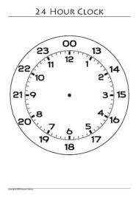
06:50am
19:15pm

Section 3: Subject tasks
Maths

Task 13: Multiplication grid

Have a go at the sums in each square and colour in
the square according the key shown. Once done,
you should see a picture. Use a calculator to help you.

Section 3: Subject tasks
Science

In Year 7 you will have the opportunity to learn about different topics in science. These include: lab safety, organisms, ecosystems, variation, electromagnets, forces and gravity, waves, sound, reproductive system and chemical reactions. You will also have the chance to do some exciting experiments along the way.

Lab safety

All students working in one of the labs in school need to be aware of the rules when working safely in a lab. Look at the picture below and circle the hazards. The write down why you think these are hazards. A hazard is a danger or a risk.

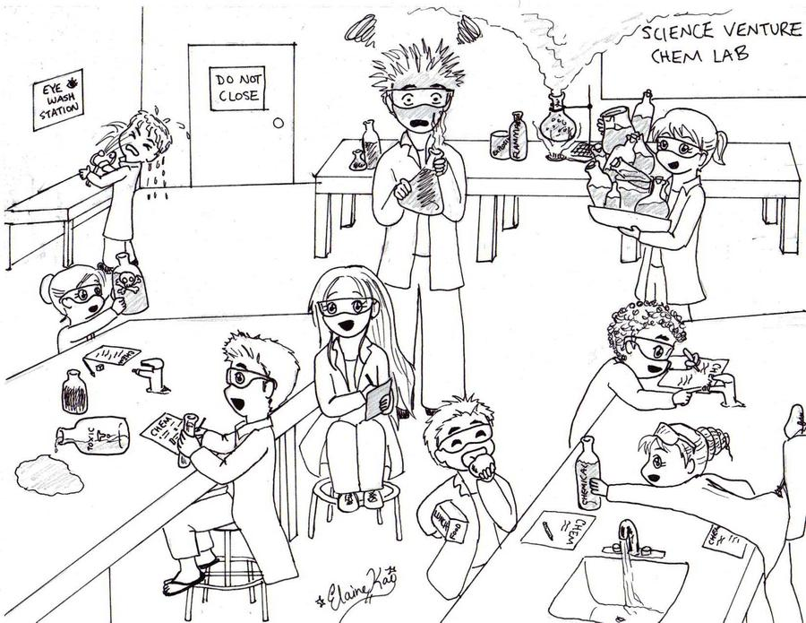

Section 3: Subject tasks
Science

Hazard table

Hazard | Why is this a hazard?

Section 3: Subject tasks
Science

Task 15: Lab safety poster

Using the space below, create a poster for how to work safely when in a science lab.

